**G-LIHT: Goddard’s LiDAR, Hyperspectral, and Thermal Airborne Imager**

*Bruce D. Cook1 and Lawrence A. Corp2*

1Biospheric Sciences Branch, NASA/GSFC, Greenbelt, MD 20771

2Sigma Space Corporation, Lanham, MD 20706

**Executive Summary**

Scientists in the Biospheric Sciences Laboratory at NASA’s Goddard Space Flight Center have conducted efforts to integrate commercial off the shelf LiDAR, hyperspectral, and thermal components to produce a compact, lightweight and portable system that can be used on a wide range of airborne platforms to support a number of NASA Earth Science research projects and space-based missions. The result of this instrument fusion effort was G-LiHT, a unique system that permits simultaneous measurements of vegetation structure, foliar spectra and surface temperatures. The complementary nature lidar, optical, and thermal data provide an analytical framework for the development of new algorithms for mapping plant species composition, plant functional types, biodiversity, biomass and carbon stocks, and plant growth. This will enhance our ability to design new missions and produce data products related to biodiversity and climate change. G-LiHT is designed to give scientists access to the data that is needed to understand the relationship between ecosystem form and function and stimulate the advancement of synergistic algorithms.

The **goal** of this instrument integration effort is to test the use of new strategy for explicit description of ecosystem type and function, using diagnostic physiological remote sensing measurements to:

• Provide new insight into the photosynthetic functionality and productivity of a range of ecosystems under diverse environmental and climate conditions;

• Build on our existing abilities to monitor changes in vegetation function, composition and structure to provide new spatially explicit remote sensing indicators of key dynamic biological processes;

• Quantify the within-biome or ecosystem spatial and temporal variation for key parameters; and

• Generate a new strategy for monitoring key dynamic ecosystem processes and using this information as inputs to models to provide increased understanding about the effects natural and human-induced changes on these ecosystems.

G-LiHT has been used to collect more than 300 hours of data for NASA sponsored studies, including NASA’s Carbon Monitoring System (CMS) and American ICESat/GLAS Assessment of Carbon (AMIGA-Carb). These acquisitions target a broad diversity of forest communities and ecoregions across the CONUS and Mexico. This white paper will discuss the components of G-LiHT, their calibration and performance characteristics, operational implementation, data processing workflows, and augment information available on the G-LiHT web site at ***http://gliht.gsfc.nasa.gov***.

**Data Products**

G-LiHT data consists of fine resolution (<1 m) ground resolution well suited for studying tree level ecosystem dynamics with the full potential of data fusion products. The single solution GPS/INS system and rigidly mounted components enables accurately co-registered data. Specific LiDAR data products consist of point cloud data (LAS format with classified ground returns and heights AGL), bare earth elevation and canopy height models, common lidar metrics (e.g., height and density percentiles). Optical data products consist of vegetation indices and spectral bio-indicators (e.g., NDVI, EVI, PRI, red-edge), at sensor radiance and surface reflectance data cubes in bil format (400-1000 nm, 5 nm FWHM), along with surface temperature. File Formats include calibrated and georeferenced data products are available in LAS (lidar point clouds), floating point GeoTIFFs (gridded products), Keyhole Markup Language file formats (flight trajectories; GeoTIFF superoverlays).

**Data Policy**

NASA’s Earth Science Program and promotes the full and open sharing of data with all users, in accordance with NASA's Data and Information Policy. Every effort has been taken by the G-LiHT team to ensure that accurate, well-calibrated data is released in a timely manner. In addition, we rely on data users to provide us with feedback to continually improve our data processing algorithms and higher-level G-LiHT products. If users should discover mistakes or anomalies in the data products, we would appreciate hearing from you. G-LiHT scientists are willing collaborators who will be able to share their scientific expertise, first-hand knowledge of the acquisitions, and unique insight on the interpretation of these data. You have the option to request collaboration and co-authorship from the G-LiHT team, but this is not mandatory to use the data. G-LiHT is a PI-lead instrument that was designed, assembled and maintained using funds from competed research grants. These funding sources should be acknowledged when publishing studies with G-LiHT data, and we request that you please contact the PI (see below) if you have questions about acknowledging G-LiHT data. Also, we would appreciate notification of your publications and presentations so that we can add them to the growing list of G-LiHT citations. The G-LiHT data archive can be accessed with your web browser or anonymous ftp application at ***fusionftp.gsfc.nasa.gov/G-LiHT***.

**Collaborators:**

NASA Goddard Space Flight Center, Biospheric Sciences Laboratory (Code 618): Branch Head Dr. Kenneth (Jon) Ranson; Physical Scientist Dr. Elizabeth Middleton; Physical Scientist Dr. Ross Nelson; Research Scientist Dr. Jeffrey Masek; Physical Scientist Dr. Douglas Morton.

NASA Langley Research Center, Flight Research Services Directorate

1. **System Components**

The G-LiHT system is comprised of commercial off the shelf components co-aligned along a uniform optical axis and assembled into a rigid and compact enclosure. G-LiHT components are aligned and rigidly mounted in a compact volume of < 0.1 m3 including centralized processing and data storage with a total system weight of 37 kg. Wire Rope Isolators (WR4-200-10, Endine Inc., Orchard Park, New York, USA) are used to mount the system to the aircraft and reduce the impact of aircraft vibrations. The system is weather resistant and can be mounted either internally to the aircraft over an appropriately sized view port or externally using a custom fabricated pod (Fig. 1). Total power consumption is 220 W with a wide input voltage range from 9 to 36 V DC. Nominal flight altitude for G-LiHT is 335 m AGL with a 60 degree FOV yielding a 387 m swath. System includes internal processing and data storage capacity controlled via a remote desktop network connection and data are recorded to ejectable 500 Gb SSD media for efficient retrieval upon conclusion of the flight. System specifications are summarized in figure 2 while detailed component specifications are described in subsequent sub sections.

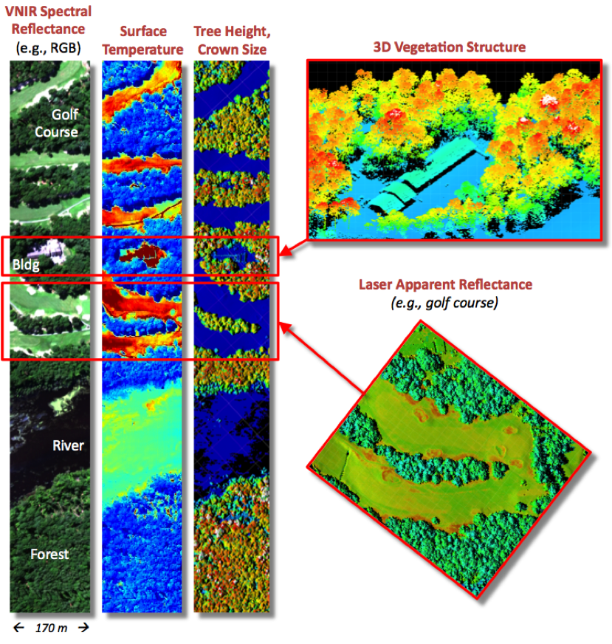

**Figure 1.** The complementary nature of LiDAR, optical and thermal data for characterizing the composition, structure, function and stress of plant communities can be seen in a single G-LiHT flight line over contrasting cover types.

|  |  |
| --- | --- |
| ***Operating Altitude*** | **335 m** |
| ***Ground Speed*** | **110 knots** |
| ***Field of View*** | **60o** |
| ***Swath*** | **387 m** |
| ***Power Consumption*** | **9-32 VDC, 210 W** |
| ***Operating temperature*** | **-10°C to 40°C** |
| ***Dimensions*** | **760x330x360 mm** |
| **Weight** | **82 lbs / 37 kg** |

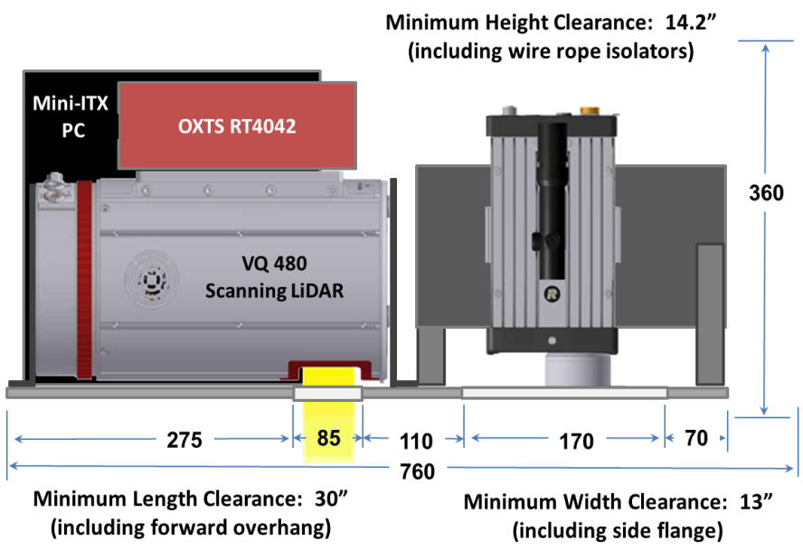

**Figure 2.** G-LiHT system specifications where minimum dimensions exclude movement during flight all other dimensions in mm.

**1.1 GPS and Inertial Navigation System (INS)**

The RT4041 (Oxford Technical Solutions, Oxfordshire, UK) is used as a single solution GPS/INS to obtain high precision position and attitude measurements. The six-axis inertial navigation system with three angular rate sensors (gyros) and three servo-grade accelerometers, incorporates an L1/L2 GPS receiver with an OmniStar HP decoder to deliver 0.1m CEP positioning and 0.1° heading accuracies. Outputs from the system are derived from the measurements of the accelerometers and gyros using a 250Hz data rate. The real time internal processing includes the strapdown algorithms (using a WGS-84 earth model), Kalman filtering and in-flight alignment algorithms. The Kalman filter monitors the performance of the system and updates the measurements to maintain highly accurate measurements and correct its inertial sensor errors. The RT4041 is connected to a G3 Antenna with active L1 Glonass + GPS + OmniStar (Antcom P/N: G3Ant-42AT1, Torrance, CA, USA). For further GPS\INS antenna specifications review appendix A1.

GPS/INS data is stored on internal SD memory in a raw, unprocessed format (rd) which can be accessed via the TCP\IP data communications port. IMU lever arm and other offset coefficients are applied via the RT Post Process software by OXTS which converts the (rd) data to a proprietary binary format, referred to as NCOM and then exported to the ASII (pos) format. During this step the inertial data is processed forwards and backwards in time and uses the best processing techniques available, including combining the results together in order to minimize the effects of GPS data drift. Where available the OmniStar HP satellite decoders is enabled giving 10cm CEP in extended periods of open sky. Increased precision can be achieved where base station GPS data is available.

|  |  |
| --- | --- |
| ***Update Rate*** | **250 Hz** |
| ***Position Acc.*** | **0.1 m** |
| ***Velocity Acc.*** | **0.07 km/hr** |
| ***Heading Acc.*** | **0.1 deg** |
| ***Acceleration Acc.*** | **0.01 m/s2** |
| ***Angle Rate*** | **0.01 deg/s** |
| ***Power Consumption*** | **10-18 VDC, 20 W** |
| ***Operating temperature*** | **-10°C to 50°C**  **Figure3.** Specifications for the OXTS RT4041 GPS/INS subsystem manufactured by Oxford Technical Solutions, Oxfordshire, UK. www.antcom.com |
| ***Dimensions*** | **234x120x80 mm** |
| **Weight** | **4.85 lbs/2.2 kg** |

**1.2 Light Ranging and Detection (LiDAR)**

Scanning and profiling lidars provide data along a continuous transect and wall-to-wall coverage for the same size swath as the G-LiHT optical and thermal imagers. The lasers operate at near- and mid-infrared wavelengths of 905 and 1550 nm, and return intensity and apparent reflectance data provide additional information the composition and distribution of elements in plant canopies.

**1.2.1 Airborne Scanning LiDAR**

The VQ-480(Riegl USA, Orlando,FL) is comprised of an integrated high-performance laser rangefinder and a rotating polygon 3 facet mirror which deflects a 1550 nm Class 1 laser beam operating at a user selectable repletion rate up to 300 kHZ along a 60o swath perpendicular to the flight direction (fig. 4). The laser beam divergence is 0.3 mrad yielding a 10 cm beam diameter at the nominal operating altitude of 335 meters. The rotating multi-facet mirror scan speed is set to 100 scans/sec providing an angle measurement resolution of 0.001 degrees. For each laser shot the echo signal is digitized and the online waveform analysis provides highly accurate range results for multiple targets supplied via the integrated Gigabit Ethernet TCP/IP interface to G-LiHT’s central computer. Each laser measurement is time tagged and accurately related to the single solution GPS/INS system via serial RS232 interface for a 1PPS TTL GPS-time input. The PC software RiACQUIRE provides a graphical user interface for scanner control and data acquisition with status feedback. RiACQUIRE is able to collect monitoring-data from the laser scanner and online data provided by the IMU/GPS-system. Based on time-synchronized scan data, position, and attitude information, scan data coverage is calculated in real time to indicate appropriate point density at the target area.

|  |  |
| --- | --- |
| **Laser Wavelength** | **http://www.riegl.com/uploads/tx_pxprieglproductscore/RIEGL_VQ-480_airborne-laser-scanner_2011-06-28_01.jpg1550 nm** |
| **Repetition Rate** | **up to 300 kHz** |
| **Measurement Rate** | **150,000 per s** |
| **Beam Divergence** | **0.3 mrad** |
| **Accuracy** | **25 mm** |
| **Scan Speed** | **100 per s** |
| **Field of View** | **600** |
| **Laser Class** | **1** |
| **Power Consumption** | **18 to 32 VDC, 65 W** |
| **Operating temperature** | **-10°C to 40°C**  **Figure 4.** Operating specifications for the VQ-480 Airborne Scanning LiDAR manufactured by Riegl, Riedenburgstrasse, Austria.  www.riegl.com |
| **Dimensions** | **360 x 219 mm** |
| **Weight** | **28.7 lbs/13 kg** |

The manufacturers RiPROCESS software is used for managing, processing, analyzing, and visualizing data acquired with the airborne system. This project-oriented software enables the user to manage and process all acquired data within a single project. Main components of data management are project information, laser scanning system information (device information, mounting information, calibration data and laser configuration), navigation device information (position and orientation of the IMU and GNSS unit), original laser data, trajectory data and tie objects. Data processing tasks include, full waveform analysis and georeferencing laser data by merging laser data and position data derived from a INS/GNSS unit. These functions are provided by the manufacturers applications RiANALYZE and RiWORLD respectively. As RiPROCESS is intended for mass data production in a multiple-workstation environment these programs may be installed on different workstations. The multiple-workstation management is done by the program RiSERVER. RiPROCESS distributes the computational load by means of individual tasks to the available server-enabled processing tools optimizing data throughput. For analyzing data can be visualized in 2D and 3D in various ways e.g. laser signal reflectivity, laser data density, color-encoded height visualization, height differences within raster cells. Even huge amounts of data can be accessed fast for display in 3D. Quality of matching different data records can be assessed in different ways, by visual inspection or by statistical analysis. RiPROCESS offers a tool to improve the calibration of the system, the relative fit of the scan data (to minimize inconsistencies between different laser data sets) and/or the absolute fit of the scan data in relation to a local/global coordinate system. This tool is named “scan data adjustment”. It allows the adjustment of several parameters such as the orientation and position offsets per laser data, per navigation device and of the Trajectory. In order to execute common tasks such as classification, triangulation and decimation by third-party software packages, RiPROCESS allows data export in the widely-used LAS format.

**1.2.2 Profiling LiDAR**

G-LiHT’s profiling lidar, the LD321-A40 (Riegl USA, Orlando,FL) is a multi-purpose laser distance meter based upon precise time-of-flight laser range measurement. Real time digital echo signal processing enables precise distance measurement for complex multi target situations resolving up to 5 target distances per pulse. This portion of the system measures a transect parallel to the flight line accurately resolving the distance between the canopy top (minimum distance function) and ground elevation (maximum distance function) along with the vertical distribution of intercepted surfaces with an accuracy of ± 50mm. The Class 1M laser diode emits at 905 nm with a beam divergence of 1.5 mrad after collimating optics to yield a 50 cm beam diameter per at the nominal operating altitude of 335 meters. The LIDAR data yields a basic geometric representation of vegetation topography where structure can be resolved with reasonable accuracy. For each laser shot the echo signal is digitized and the online waveform analysis provides highly accurate range and amplitude results for up to 5 targets. Each laser measurement is time tagged and accurately related to a single solution GPS/INS system. Data transmission and system configuration are accomplished through a TCP/IP, 10/100 Mbit Ethernet connection to the central PC.

|  |  |
| --- | --- |
| **Laser Wavelength** | **905 nm** |
| **Repetition Rate** | **10 kHz** |
| **Measurement Rate** | **up to 10 kHz** |
| **Beam Divergence** | **1.5 mrad** |
| **Accuracy** | **50 mm** |
| **Laser Class** | **1M** |
| **Power** | **12 to 28 VDC, 18 W** |
| **Operating temperature** | **-10°C to 50°C** |
| **Dimensions** | **248 x 130 x 112 mm** |
| **Weight** | **6.4 lbs/2.9 kg** |



**Figure 5.** Operating specifications for the LD321-A40 laser distance meter manufactured by Riegl, Riedenburgstrasse, Austria.

**1.3. Hyperspec Imaging Spectrometer**

The major components of the hyperspectral imaging system are comprised of the HyperspecTM VNIR Concentric Imaging Spectrometer (Headwall Photonics, Fitchburg, MA) and the ruggedized RA1000m/D digital fine gain imaging camera (Adimec, Stoneham, MA). The Hyperspec spectrometer enables high spectral and spatial resolution imaging through high efficiency f/2.0 telecentric optics and a high efficiency aberration-corrected convex holographic diffraction grating, providing an optical dispersion of 100 nm per mm over a 7.4 mm spatial by 6.0 mm spectral focal plane. The concentric spectrograph, based on the Offner design, enables imaging from 400-1000 nm over the full extent of an 18 mm tall 25 microns wide entrance slit. Hyperspec imaging spectrometer accepts a C-mount objective lens (Cinegon f/1.4 8mm, Schneider Optics, Hauppauge, NY) with high optical performance using ultra low dispersion glass and special broadband anti-reflection coating designed for enhanced visible to near-IR precision imaging. Coupled to the spectrometer is the RA1000m/D high speed rugged megapixel focal plane array allowing the acquisition of up to 75 progressive frames per second acquired through the PIXCI ECB1 PCI Express x4 base CameraLink interface. The camera uses a 1/2 inch interline 12 bit CCD imager in a 1004x1004 format with 7.4 micron pixels. Camera features include: a digital fine gain for adjustable camera sensitivity over a 60 dB dynamic range, electronic shuttering, low smear characteristics, and offers ruggedized military specifications for severe operating environments. The camera is fully software controlled via a G-LiHT’s internal PC with the serial communication channel of the CameraLink interface. Each image frame is coded with a PC timestamp synchronized with the common solution GPS/IMU system. Low altitude acquisitions and cross-calibration of a downwelling and upwelling spectrometers allows us to compute surface reflectance with minimal atmospheric effects.



|  |  |
| --- | --- |
| **Wavelength Range** | **400-1000 nm** |
| **Aperture** | **F/2.0** |
| **Dispersion per pixel** | **0.72nm** |
| **Slit Width** | **25μm** |
| **Slit Length** | **18mm** |
| **Spectral Resolution** | **5 - 6 nm** |
| **Spectral Bands** | **402** |
| **Spatial Bands** | **1004** |
| **Dynamic Range** | **68 db** |
| **Frame Rate** | **50 fps** |
| **Weight** | **6.7 lbs/3.0 kg** |

**Figure 6.** Operating specifications for the HyperspecTM VNIR Concentric Imaging Spectrometer manufactured by Headwall Photonics, Fitchburg, MA. FOV = 2arctan(d/2f) = 49.64 deg, where f=8 mm lens and d=7.4 mm.

**1.4. Downwelling Radiometer**

Downwelling radiance is measured by G-LiHT using the Ocean Optics USB 4000-VIS-NIR spectrometer (Dunedin, Fl, USA). Light energy is transmitted to the spectrometer through an upward looking opaline glass cosine diffuser with an 180o FOV. A 3m 100µm single-strand optical fiber delivers the light energy through a 25 µm entrance slit and a multi-bandpass order-sorting filter. It then disperses via a fixed grating across a 3648-element Toshiba linear CCD array. The spectrometer covers the spectral range from 350 to 1100 nm with a native optical resolution to ~1.5 nm (FWHM). Power and communications occur through a USB 2.0 connection to the central PC. The downwelling radiometer is radiometrically cross calibrated with the imaging spectrometer to enable atmospheric characterization, downwelling irradiance, used to provide enhanced surface reflectance product.

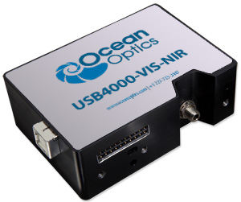

|  |  |
| --- | --- |
| ***Array type*** | **Linear CCD** |
| ***Spectral band*** | **350 to 1000 nm** |
| ***# Pixels*** | **3648** |
| ***Pixel pitch*** | **8 x 200 µm** |
| ***SNR*** | **300:1** |
| ***Configured Data Rate*** | **1 Hz (16 bit)** |
| ***Operating temperature*** | **-40°C to 50°C** |
| ***Dimensions*** | **89 x63x34 mm** |
| ***Power consumption*** | **250mA @ 5VDC** |

**Figure 7.** System specifications for the Ocean Optics USB 4000-VIS-NIR spectrometer (Dunedin, Fl, USA).

**1.4 Thermal Imaging**

G-LiHT’s thermal sensing capability originates from the Gobi-384 thermal imaging camera (Xenics, Leuven, Belgium). The broad band long wave infrared (LWIR) spectral range from 8 to 14 µm is covered by a uncooled a-Si microbolometer detector array (resistive amorphous silicon, FPA) with 384 cross track pixels and a 30o FOV. This compact component measuring 72 x 60 x 50 mm uses a Gigabit Ethernet TCP/IP interface to deliver 16-bit ratiometrically calibrated thermal imaging data to G-LiHT’s central computer running the Xenith software and graphical user interface. Each image frame is coded with a PC timestamp synchronized with the common solution GPS/IMU system.

|  |  |
| --- | --- |
| ***Array type*** | **Microbolometer** |
| ***Spectral band*** | **8 µm to 14 µm** |
| ***# Pixels*** | **384 x 288** |
| ***Pixel pitch*** | **25 µm** |
| ***Sensitivity (NETD)*** | **> 50 mK @ 30°C** |
| ***Frame rate (full frame)*** | **25Hz (16 bit)** |
| ***Operating temperature*** | **-40°C to 50°C** |
| ***Focal length*** | **18 mm f/1** |
| ***Power consumption*** | **3.6 W @ 12V** |

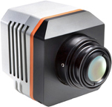

**Figure 8.** System specifications for the Gobi-384 LWIR thermal imaging camera manufactured by Xenics, Leuven, Belgium. www.xenics.com

**1.5 Integrated PC**

G-LiHT’s internal PC consists of the Jetway JC-111-B compact chassis with dual expansion slots and with a DC-DC wide input range M4-ATX power supply (Logic Supply, South Burlington, VT, USA). The PC uses a ZOTAC GF9300-I-E LGA 775 Mini ITX motherboard with the Intel Q9550S Yorkfield 2.83GHz 65W Quad-Core desktop processor and 8GB of PC2 6400 dual channel desktop memory. The PCIe expansion slot contains the PIXCI® EL1DB (EPIX, Buffalo Grove, IL, USA) dual base camera link frame grabber for 204 MB/s sustained data transfer of imaging spectrometer data. The motherboard Gigabit Ethernet, USB 2.0, and COM ports are relied on for simultaneous control and data transfer of all remaining G-LiHT components. Data is written to two 512 Gb SATA II solid state disks (one fixed mounted and one ejectable) with up to 180 MB/s sustained sequential write capability. User interfacing is accomplished via direct connection or useing an Ethernet remote desktop connection to either a laptop or rack mount general purpose PC.

|  |  |
| --- | --- |
| ***PC Form Factor*** | **Mini-ITX** |
| **Processor** | **I5 Quad Core** |
| **Memory** | **PC26400, 8Gb** |
| **EPIX Frame Grabber** | EL1DB **PCIe x4** |
| **Power Supply** | **M4-ATX, 250 W** |
| **Operating System** | **Win 7** |
| ***Operating temperature*** | **-40°C to 50°C** |
| ***Dimensions*** | **89 x63x34 mm** |
| ***Power consumption*** | **9 to 32 VDC, 105 W** |

1. **Spectral Calibration**

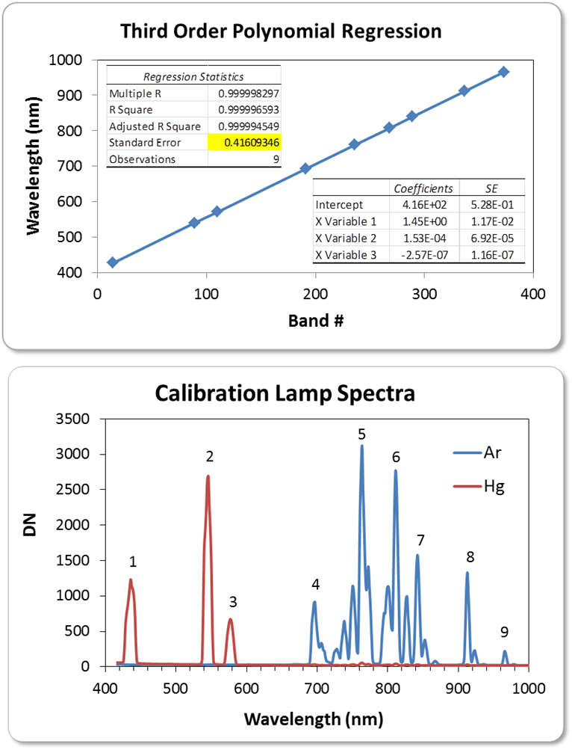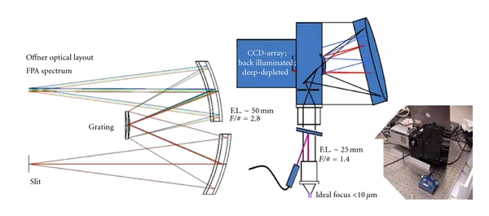The HyperspecTM VNIR Concentric Imaging Spectrometer’s telecentric optics and high efficiency aberration-corrected convex holographic diffraction grating offers precision imaging with a high degree of spatial spectral uniformity (Fig. 9). Typical operation of the imaging spectrometer is with 2x at sensor spectral binning yielding 402 spectral bands with a 1.5 nm sampling resolution. A teflon integrating sphere with 9 pronounced Hg & Ar pen lamp emission lines as viewed through the imaging spectrometer are shown in Figure 10. These calibration lamp specta are used to map spectral channels to wavelength over the spectral range from 417 nm to 1007.8 nm with sub-nanometer precision (Fig. 11). A similar approach is used to assign wavelengths to G-LiHT downwelling radiometer. Both the imaging spectrometer and downwelling radiometer are periodically monitored for wavelength stability and drift.

**Figure 9.** Optical schematic for Offner concentric imaging spectrometer.

**Figure 10.** Hg & Ar pen lamp emission lines as viewed through G-LiHT’s imaging spectrometer.



**Figure 11.** Third order polynomial regression results for mapping imaging spectrometer bands to spectral wavelength with a standard error of 0.4 nm.

Spectral response functions for G-LiHT’s imaging spectrometer were generated using a monochromatic light source consisting of a 450 W xenon short-arc mounted vertically in an air-cooled housing with light collection and focusing by off-axis mirror to the Gemini 180 double-grating monochrometer (HORIBA Instruments Inc., Edison, New Jersey, USA) with kinematic 1200 grooves/mm grating and all reflective optics for high stray-light rejection. The adjustable slits at the entrance and exit apertures set 1 mm yielding a 2.1 nm FWHM bandpass. Spectral response functions for each spectral band were accurately modeled using a Gaussian iterative cure fitting approach yielding a mean FWHM of 6 nm. Wavelength and FWHM for each spectral band along with image dimensions are reported in each bil header (hdr) meta file .

**3.0 VNIR Radiometric Calibration**

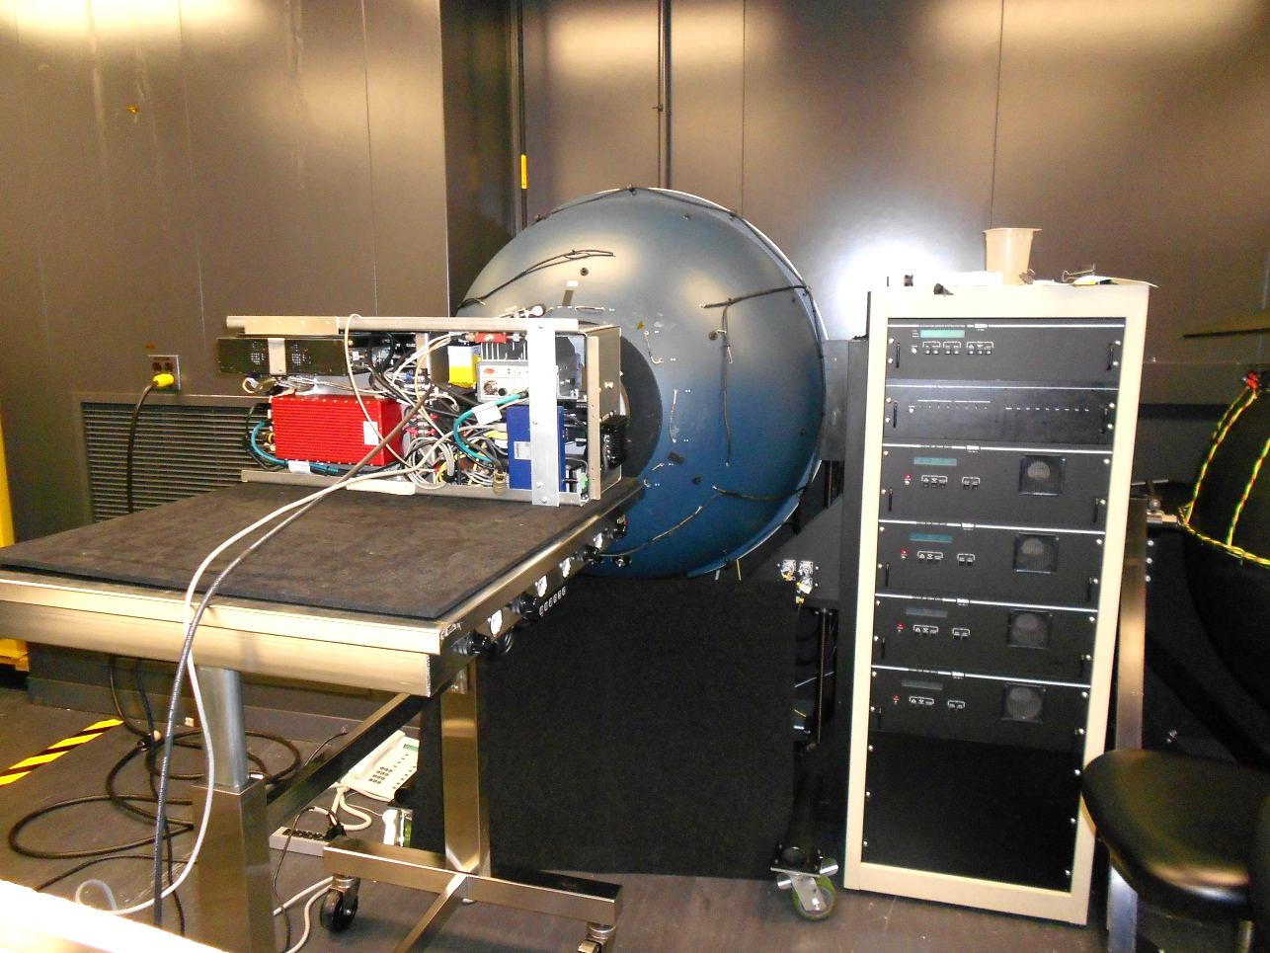GSFC’s Calibration Facility (CF) Labsphere 42” large aperture NIST traceable uniform source is used to perform and periodically verify the radiometric calibration of G-LiHT’s imaging spectrometer and downwelling radiometer.



**Figure 12.** G-LiHT system placed at the exit aperture of Goddard’s Calibration Facilities radiometric calibration source. http://cf.gsfc.nasa.gov/.

**Figure 13.** Radiometric calibration coefficients are generated and periodically verified by conversion of spectrometers raw DN to radiometric intensities of the calibration source.

**4.0 Thermal Radiometric Calibration**

G-LiHT’s thermal imaging camera has factory radiometric calibration for surface temperatures between -20°C and 120°C with a NETD > 50 mK. Thermal calibration stability as a function of microbolometer operating temperature range of 25oC to 50oC is verified against GSFC CF’s blackbody over the temperature range of -5oC to 85oC (Fig. 14).



**Figure 14.** Radiometric response of the for the Xenics Gobi-384 LWIR thermal imaging camera as a function of device temperature.