Data collection and methods
Lidar data was collected using NASA Goddard’s Lidar Hyperspectral, and Thermal (G-LiHT) multi-sensor airborne imaging system, which simultaneously measures vegetation structure, foliar spectra and surface temperatures (Cook et al., 2013). During 2017, the G-LiHT lidar system was improved by upgrading the existing Riegl model VQ-480 lidar to a VQ-480i (Horn, Austria); adding a second VQ-480i lidar; and upgrading the GPS-INS to an Applanix POS AV V6 (Richmond Hill, Ontario, Canada). Each lidar emits a 1550 nm laser pulse with 0.3 mrad beam divergence, which produces a footprint of ~10 cm diameter at a nominal acquisition height of 335 m Above Ground Level (AGL). A laser pulse repetition frequency of 300 kHz and nominal air speed of 130 kts produces a lidar sampling density of ~12 laser pulses m⁻². The high density of small footprint lidar measurements provides a very detailed 3D structure of mangrove forests, which is not possible with space-based systems with greater pulse duration, larger target footprints, and sparser sampling. Laser energy at 1550 nm is strongly attenuated by water and does not penetrate open water bodies. Open water body elevations were measured by specular reflection of laser energy in the near-nadir direction and from areas where wind and turbulence created waves or ripples on the water surface.
G-LiHT GPS-INS data were post-processed with Applanix POSPac Mobile Mapping Suite 8 georeferencing software (MMS; Richmond Hill, Ontario, Canada) and Trimble Post-Processed CenterPoint RTX global GNSS correction service (PP-RTX; Sunnyvale, CA, USA), which provides cm-level positioning accuracy by utilizing a global network of tracking stations to reduce ephemeris, timing and atmospheric uncertainties. All geographic coordinates were projected in Universal Transverse Mercator (UTM Zone 17N for south Florida), using WGS-84 (World Geodetic System 1984) and EGM96 (Earth Gravitational Model 1996) as horizontal and vertical datum, respectively.
Riegl’s RiPROCESS software was used to manage, process, analyze and visualize Level 0 data from the laser scanner and GPS-INS. Data processing involved data import and calibration; waveform analysis and correction for Multiple-Time-Around (MTA) ambiguities; georegistration of discrete returns using precision GPS-INS data; and export of point cloud data. Higher-Level G-LiHT products (e.g., aircraft trajectory in ASCII format; LAS files with AGL height and classification for each return; gridded elevation and AGL height models, apparent reflectance, plot-scale statistics, and change maps in GeoTIFF format) were produced by algorithms custom coded in IDL-ENVI (Interactive Data Language and Environment for Visualizing Images; Exelis Visual Information Solutions, Boulder, CO, USA). These workflows are described in Cook et al., 2013 and available for visualization and downloading through the G-LiHT webpage (https://gliht.gsfc.nasa.gov) and interactive data center (https://glihtdata.gsfc.nasa.gov).
Ground returns were classified using a Progressive Morphological Filter (Zhang et al., 2003), and a Triangulated Irregular Network (TIN) surface was used to interpolate the ground elevation and create a Digital Terrain Model (DTM) for each 1 m⁻² grid cell without ground returns. A Canopy Height Model (CHM) was generated by creating a TIN from the highest non-ground returns, interpolating the elevations to grid cell centroids, and subtracting canopy elevation, or Digital Surface Model (DSM), from the DTM to compute height in units Above Ground Level (AGL). An example of post-hurricane mangrove DTM, CHM and lidar point cloud are shown in Figure 2.
Repeat acquisitions over stationary targets without trees (e.g., buildings, roadways) demonstrated a swath-to-swath repeatability of 10 cm (1 σ) absolute elevation following boresight alignment, and similar differences were observed between subcanopy ground elevations computed for March 2017 and December 2020 (data not shown).

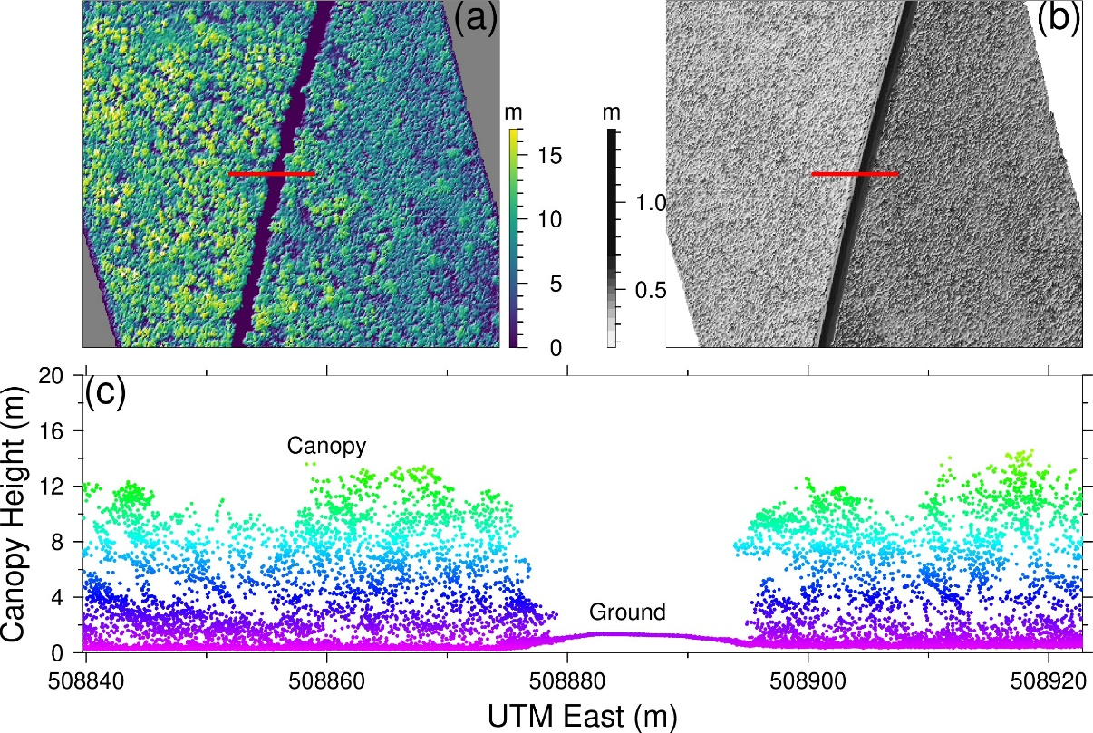
Figure 2. Airborne lidar data was collected over south Florida three times between 2017 and 2020. An example (a) Canopy Height Model (CHM), (b) Digital Terrain Model (DTM), and (c) point cloud profile of mangrove forest across the road near Flamingo were acquired on December 6, 2017. Red lines in (a) and (b) show the forest point cloud profile location in (c).

Three repeat G-LiHT airborne lidar surveys flew over the Florida Everglades. The first flight occurred in March 2017, the second 3 months after Hurricane Irma in December 2017, and the third in March 2020. The surveyed area for each flight campaign covered an approximate area of over 130,000 ha across south Florida. This is one of the largest collections of airborne lidar data that has been acquired within months before and after a major hurricane, capturing the immediate impacts of the storm, as well as the long-term recovery. All CHMs are available to download through the G-LiHT webpage (http://G-LiHT.gsfc.nasa.gov) and the point cloud data are also distributed by LP DAAC (https://lpdaac.usgs.gov/). There are 1983, 1453, and 930 CHMs in March 2017, December 2017, and March 2020, respectively. The length of each CHM is ~1 km, but the width of CHM varies depending on the swath configuration during the flight.
We calculated the difference of CHMs for post-Irma damage (March 2017 – December 2018), post-Irma recovery (December 2018 – March 2020), and 2.5 years of regrowth (March 2017 – March 2020) at 1 m resolution on mangrove forests across the Everglades. We grouped the CHMs based on the resilience and vulnerability models developed from Landsat time series following Hurricane Irma (Lagomasino et al., 2021). The mangrove forest resilience classes are separated into three categories: low, intermediate, and high and are based on the magnitude of forest greenness loss and the slope of the Normalized Difference Vegetation Index (NDVI) following the storm (Lagomasino et al., 2021). For example, in low resilience regions, the recovery time is over 15 years, while the recovery time is within 5 years in high resilience areas. We used gdalwarp in gdalUtils library of the R statistics software to transform the coordinates system of the resilience map from WGS84 to UTM zone 17N. Resolution of the resilience map is upsampled from 30 m to 1 m using projectRaster with nearest neighbor interpolation method. Then the reprojected resilience map in UTM coordinates is used as a mask to group raster cells in CHMs into low, intermediate, and high resilience classes. Canopy height frequency distribution models in March 2017, December 2017, and March 2020 are calculated and presented in each resilience class.
Using the CHM time series, we quantify the changes in canopy height regrowth according to height classes and species classes. The pre-storm mangrove canopy height map was subdivided into five classes (0–5 m, 5–10 m, 10–15 m, 5–20 m, and >20 m) to compare the mangrove forest structure and quantify the damage and regrowth in each class. CHMs in March 2017 are regarded as the pre-storm canopy map and processed as masks for CHMs in December 2017 and March 2020. Statistical metrics including mean, area, and standard deviation are calculated for each class. Vegetation maps developed by the National Park Service (i.e., Region 2, 3, and 4) (Ruiz et al., 2021) were used to identify key mangrove vegetation communities. We considered five dominate vegetation cover classes: 1) A. germinans, 2) L. racemosa, 3) R. mangle, 4) Conocarpus erectus (Buttonwood mangrove), and a 5) single mixed species mangrove class. Each species class distribution was used as a mask to filter G-LiHT data that was observed within the respective class. Boxplots and statistical analyses for those five vegetation cover classes are presented.
We tested the significant differences between canopy height and vegetation cover classes using the Tukey HSD Test in R (version 4.1.3). The Tukey HSD Test can compare all possible pairs and distinguish when two groups are significantly different if their means have a difference more than honestly significant difference (HSD). In addition, we conducted a two-sided Kolmogorov-Smirnov statistics (KS) test in R (version 4.1.3) to measure the difference in the canopy height cumulative distribution curves between pre-storm, post-storm, and regrowth in different resilience groups and species groups.

